**CMPE 310: System Design and Programming**

**Lab Cover Page**

**Lab # 5**

**Lab Title Hardware Project**

**Names Andrew Mathew, Christian Lostoski, Mick Harrigan, Xavier Smith**

**Section 3**

**Date Submitted :5/16/2021**

**TA / Grader Use Only:**

**Late Submission Deduction (5% 1st Day late, 25% 2nd Day late):**

**Other Deductions:**

**Final Lab Grade:**

**Comments to student:**

Table of Contents

**1. General** 5

1.1. Technical Document General Description 5

1.2. Technical Document Organization 5

**2. 8086 Microprocessor** 6

2.1. Description 6

2.2. Pinout 6

2.3. Address Bus 7

2.4. Data Bus 7

2.5. Control Bus 8

2.6. Non-Maskable Interrupt Button 8

2.7. Power 8

**3. Memory** 9

3.1. CMOS Flash Memory 9

3.1.1. 28F010 Device Description 9

3.1.2. KiCad Schematic 9

3.1.3. Flash Memory Implementation 9

3.2. SRAM 10

3.2.1. CY7C199 Device Description 10

3.2.2. Interfacing Memory Banks 10

**4. Decoding Process** 12

4.1. 16L8 Device Description 12

**5. 8284A Clock Generator** 13

5.1. General Description 13

5.2. Reset Subcircuit 13

5.3. Kicad Schematic 13

5.4. Pin Configuration 14

5.5. Internal Block Diagram 14

**6. 8255 Chip** 15

6.1. Device Description 15

6.2. I/O Port Assignments 15

6.3. Pin Configuration 15

6.4. Kicad Schematic 16

**7. 8259 Interrupt Controller** 17

7.1. Device Description 17

7.2. Pinout 17

**8. 8254** 18

8.1. Device Description 18

8.2. Counter Select 18

8.3. Pin Configuration 19

8.4. Internal Architecture 19

8.5. Kicad Schematic 20

**9. 8279** 21

9.1. Device Description 21

9.2. Pinout 21

9.3. Keyboard 21

**10. 16550 UART** 22

10.1. Device Description 22

10.2. MAX235 & DSUB 23

**11. LCD Display** 25

11.1. LCD Description 25

11.2. Pinout 25

**12. 7 Segment Displays & LEDs** 26

12.1. Seven Segment Displays 26

12.1.1. Description 26

12.1.2. Front and side view 26

12.1.3. Display and LED control Bytes 26

12.1.4. KiCad Schematic 27

**13. 74244 8 DIP Switches** 28

13.1. 74LS244 Description 28

13.1.1. 74LS244 Description 28

13.1.2. Pinout 28

13.2. DIP Switch Description 28

**14. Work Distribution** 29

**15. Bill of Materials** 30

**16. Block Diagram** 34

**17. 3D Model** 35

**18. Hierarchical Schematic** 36

**19. Full Schematic** 36

**20. Data Sheets** 38

# **General**

## Technical Document General Description

This document entails the 8086 circuit board that was created as a standalone board. The board handles the basic needs of a simple computer and its inputs with a keyboard, and outputs with different displays. The different sections of this document show the usages of each of the chips used, and how they interconnect with one another.

## Technical Document Organization

The following sections of this show the pinouts of each chip, background on each chip, wiring diagrams for the connections between each chip and those that it locally uses, as well as a global connection list of the connections.

# **8086 Microprocessor**

## Description

The Intel 8086 high performance 16-bit CPU is available in three clock rates: 5, 8, and 10 MHz. The CPU is implemented in N-Channel, depletion load, silicon gate technology (HMOS-III). The 8086 operates in both single processor and multiple processor configurations to achieve high performance levels. The internal functions of the 8086 processor are partitioned logically into two processing units. The first is the Bus Interface Unit (BIU) and the second is the Execution Unit (EU) as shown in the block diagram.

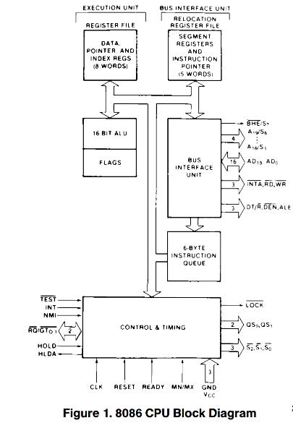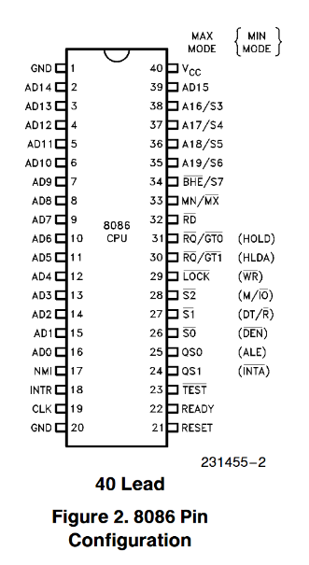

## Pinout

* AD­15-AD0 (1-16, 39): Address/Data Bus
* A16-19/S3-6 (35-38): Address/Status
* BHE/S7 (34): Bus High Entable/Status
* RD (32): Read
* READY (22): Ready
* INTR (18): Interrupt Request
* NMI (17): Non-Maskable Interrupt
* RESET (21): Reset
* CLK (19): Clock
* VCC (40): Power supply pin
* GND (1, 20): Ground
* MN/MX (33): Minimum/Maximum
* M/IO (28): Status Line
* WR (29): Write
* INTA (24): Interrupt Acknowledge
* ALE (25): Address Latch Enable
* DT/R (27): Data Transmit/ Receive
* DEN (26): Data Enable

## Address Bus

The address bus from the 8086 is connected to 3 74LS373s separated by AD[0..7], AD[8..15], and A[16..19]. They are controlled by the ALE pin.

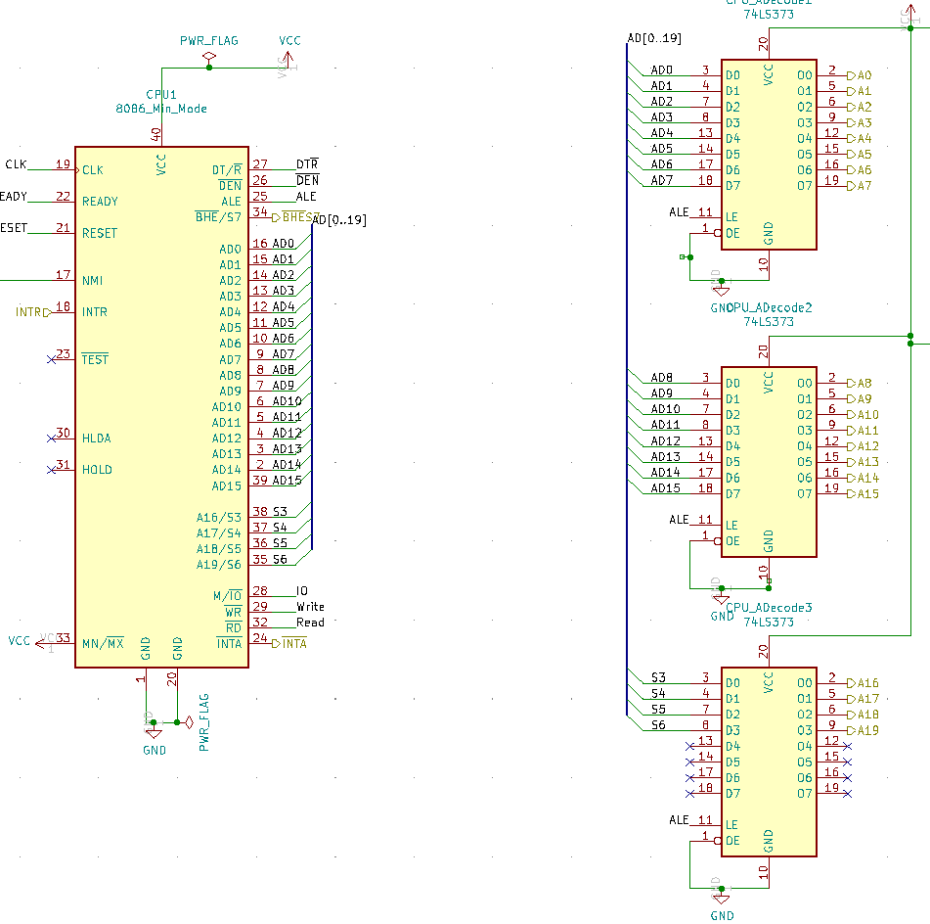

## Data Bus

The data bus is a multiplexed bus with the address pins and the data pins. The Data bus goes to two 74LS245s with the first taking AD[0..7] and the second taking AD[8..15]. They are controlled by the DT/R and DEN pins.

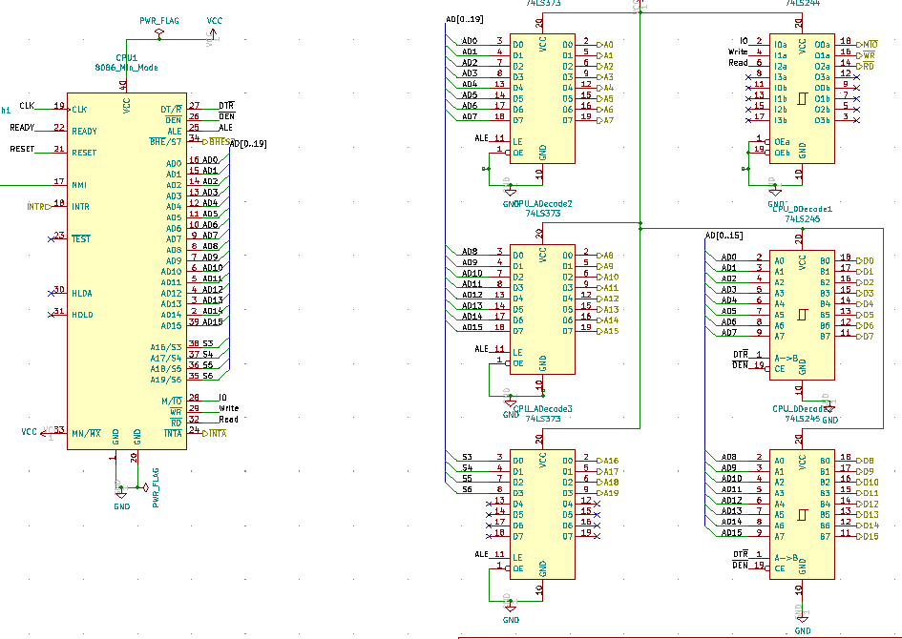

## Control Bus

The control bus signals specific memeory locations and I/O devices. It is a It is driven by the M/IO, WR, and RD and outputs those pins. It goes into a line driver, the 74LS244.

## Non-Maskable Interrupt Button

The NMI is in use whenever the 8086 processor has any form of error. This could be a parity error, power error, or many other types of errors.

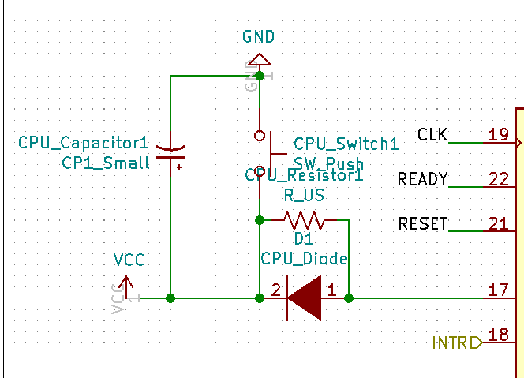

## Power

This power block provides the entire board with power and uses 26 capacitors. It will produce 100uF of capacitance.

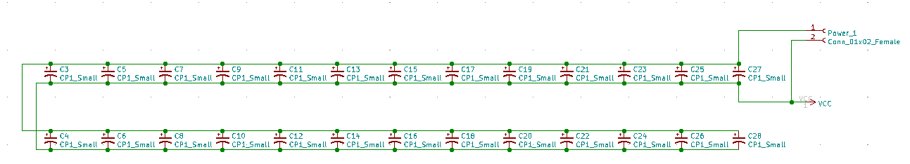

# **Memory**

## CMOS Flash Memory

### 28F010 Device Description

The 28F010 is an individual CMOS memory chip that has read/write access, has random access non-volatile memory, and can be cascaded. Each 28F010 has the ability to store up to 128KB (bits) of memory, which is 16384 bytes of memory. Each chip has 17 address inputs, and 8 data input/outputs, which allows a wide range of memory addresses to be stored. There is a program power supply for programming purposes (VPP), an external power port (VCC), and ground (VSS). Along with being able to be reprogrammed internally, the 28F010 has the ability to switch between read and write modes, where the read-only mode is used to protect the memory, and read / write mode used to edit and erase what may be stored.

### KiCad Schematic

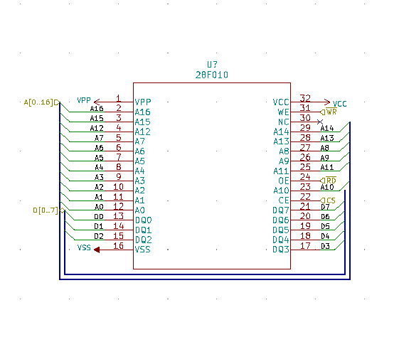

### Flash Memory Implementation

The Flash Memory Implementation is integrated within the 8086, and is a cascade of individual 28F010’s. Particularly, the full implementation contains 2 28F010’s, where they are decoded at a specific address, (FFFFFH). This means that the max address that the Flash Memory can hold is FFFFF, (the H stands for hex). Using a 74LS138 (or a special 3 to 8 decoder), the addresses are separated into even and odd, where the highest bank has the even addresses and the lowest bank had the odd addresses. Each 28F010 has 128K of space, and we have 2 total, so the total space that the Flash Memory has is 256K.

* + 1. KiCad Schematic

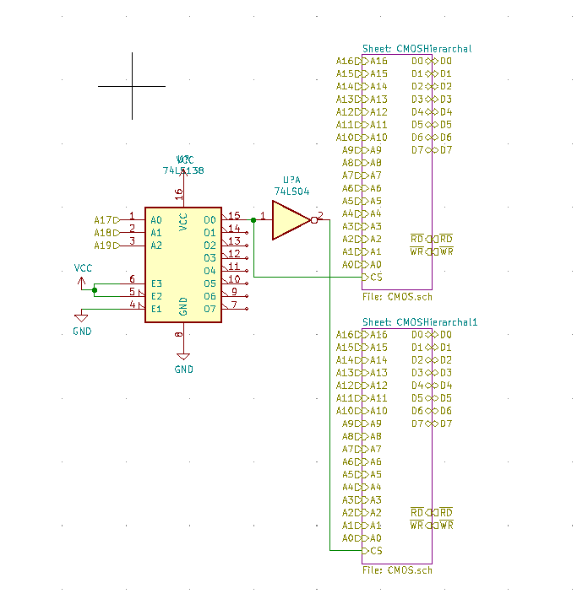

## SRAM

### CY7C199 Device Description

The CY7C199 is an asynchronous SRAM Module with power efficient modes for scalable use. Multiple chips can have their outputs bussed together to make one larger data bus for both the high and low end of the bit spectrum.

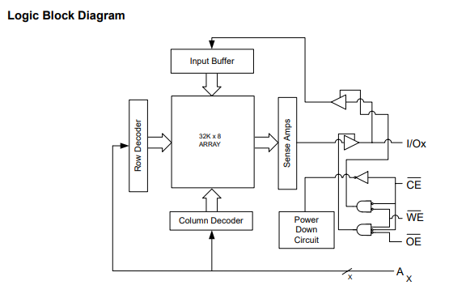

### Interfacing Memory Banks

The given configuration of the 8086 has 128k of SRAM derived from 4 of these chips. They are decoded into 2 banks, one that is high and the other that is low. This outputting is defined by the inputs within the 16L8 that is used to decode the addressing bits. This is then combined with the Bus High Enable pin from the CPU to determine if the data is the high or the low bank.

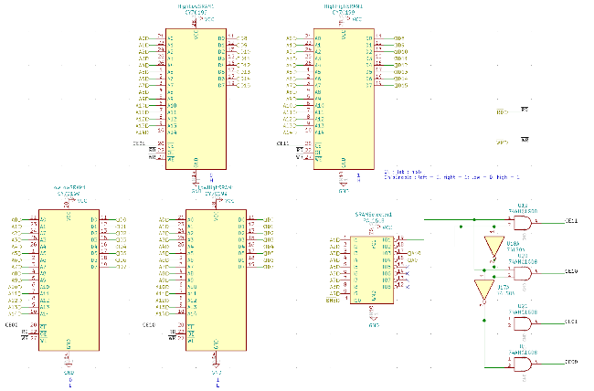

# **Decoding Process**

## 16L8 Device Description

The 16L8 is a programmable 10 input 8 output logic device that is used frequently in this circuit board. Each of the cases that the chip is used it is for the chip selection based on the different addresses being passed into the section. Each use case shows the outputs and inputs for the given chips being selected and how the 16L8 connects the CPU and other devices.

Used in LCD Array, DIP Switches, CMOS, SRAM, 8255, 8259, 8254, 8279, 16550, 7-Segment Display.

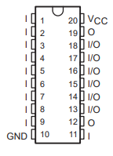

# **8284A Clock Generator**

## General Description

The 8284A clock generator is an integral part of the 8086-microprocessor board. It’s the clock that helps run the entire microprocessor. Without it, so many components would need to generate their own clock signals. For example, the 8086 needs the CLK signal from the 8284A, additionally the UART chip, and the 8279 require the PCLK from the clock generator. The clock generator alleviates the issue of having multiple clocks and helps the microprocessor stay cost-friendly, efficient, and less space is required on the board by having a clock generator compared to multiple components each having their own clocks. As described in chapter 9 of the textbook, the 8284A has the following functions: clock generation, reset and ready synchronization, as well a peripheral clock signal otherwise known as PCLK.

## Reset Subcircuit

As seen in the Kicad Schematic, the reset subcircuit has a resistor, capacitor, and a switch to ground. By doing the reset this way utilizing an RC network, it provides a power-on reset for the reset pin which is an active low input.

## Kicad Schematic

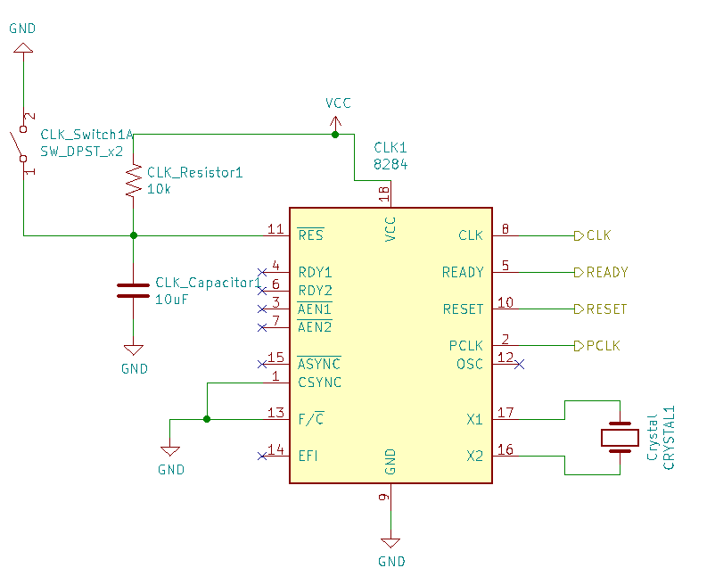

## Pin Configuration

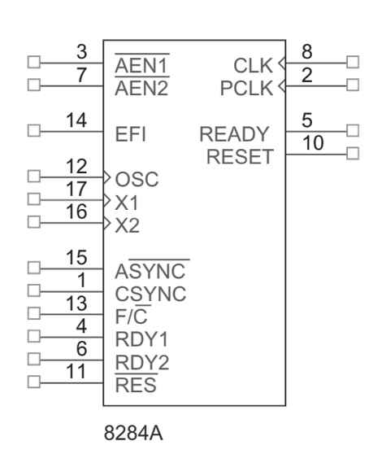

## Internal Block Diagram

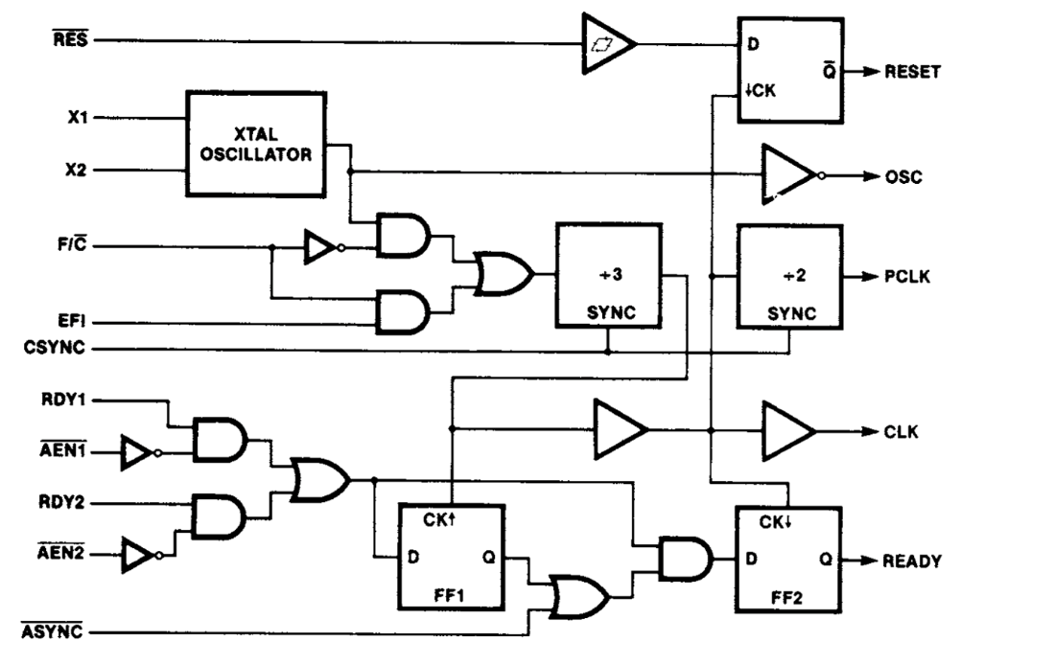

# **8255 Chip**

## Device Description

The 8255 chip is a programmable peripheral interface (PPI). It’s an Input/Output (I/O) device that helps connect the CPU to peripherals or other I/O devices. For example, it could connect the 8086 with a keyboard, or an analog to digital converter, or other external devices. The great thing about it is its adaptability due to the fact that it’s programmable. It has 3 different ports labeled PA, PB, and PC that are programmed as groups. There are 3 8255 chips each decoded at separate addresses, the chip needed will be selected through its chip select (CS) which is an active low input. After selecting the chip needed in order to read or write to a port, the corresponding register has to be selected by the A0 and A1 pins on the chip. An important note is that the 8255 has three different modes of operation, in mode 0 it functions as a buffered input or latched output device, in mode 1 it uses a Handshake I/O mode, and in mode 2 it uses a bi-directional data bus mode. However, when the chip is reset the default mode is mode 0.

## I/O Port Assignments

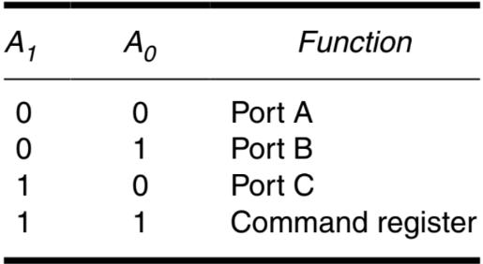

## Pin Configuration

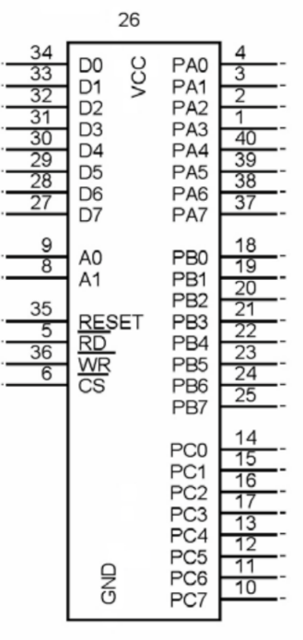

## Kicad Schematic

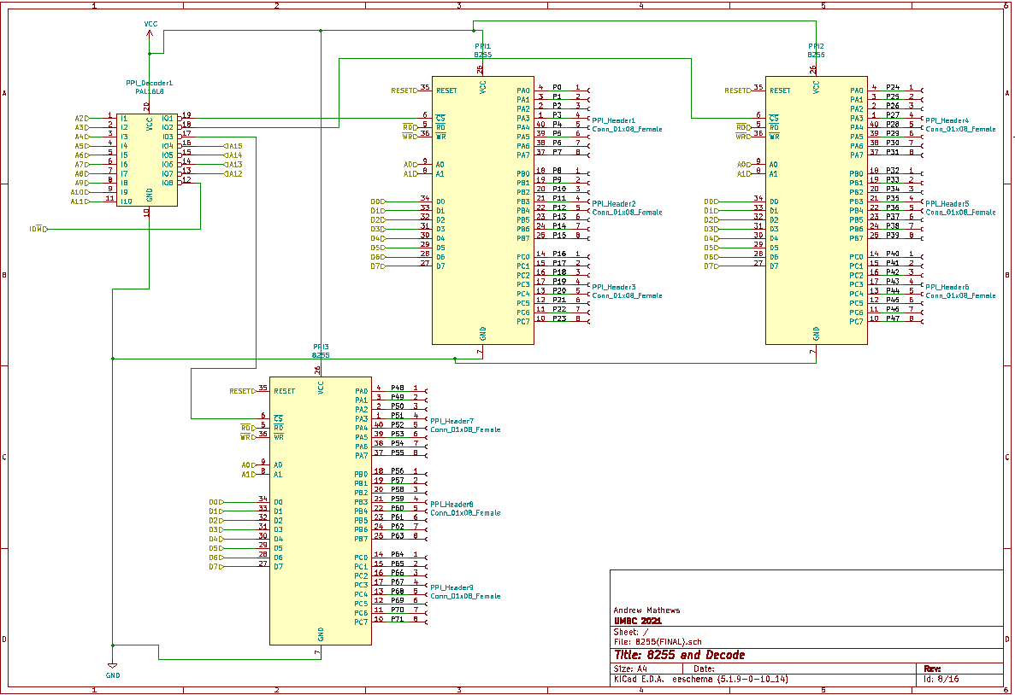

# **8259 Interrupt Controller**

## Device Description

The 8259 chip connects between multiple other chips to relegate the interrupt data towards the 8086 CPU. This is done through connections of different chips to the input interrupt pins and a master output for the CPU.

8086 reads in from the INTR pin and uses the INTA pin to acknowledge that assigned interrupt.

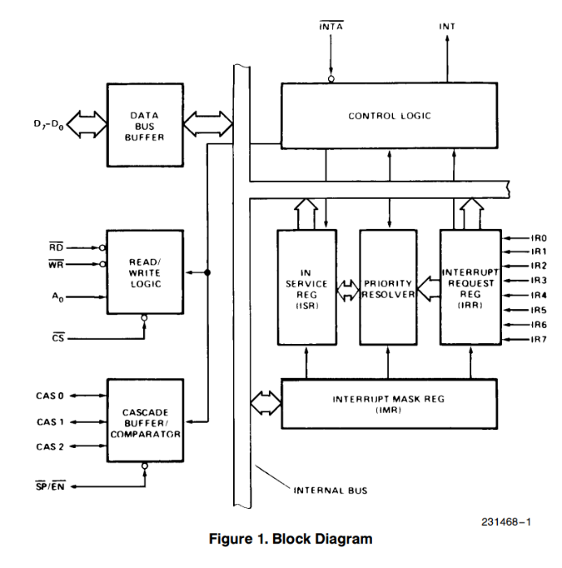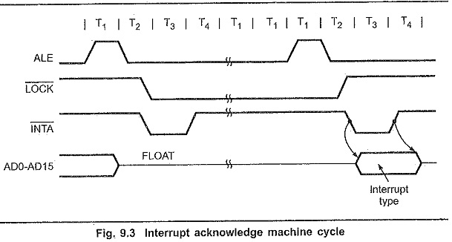

## Pinout

* IR0 – direct connection via a switch to interrupt the CPU
* IR1 – input from the 8254 second counter register
* IR2 – input from the 16550 UART for interrupting the CPU on data transmission
* IR4-7 – no direct connection
* WR – connected to the CPU for instructions to be written to the data pins
* RD – connected to the CPU for instructions to have the data read back into the CPU
* INT – output pin that connects to the CPU for master interrupts
* INTA – output pin that connects to the CPU for interrupt acknowledgement
* A0 – connected to the A1 address pin from the CPU to understand when it is being signaled
* CS – chip select from the 16L8 for when the chip is to be run
* SP/EN - driven high to stop all master/slave communication

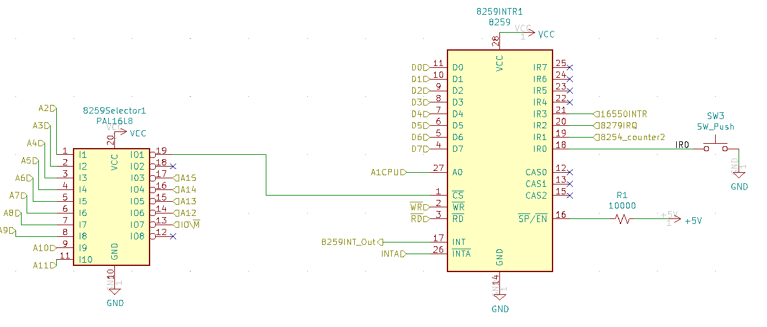

# **8254**

## Device Description

The 8254 is a programmable interval timer and within the chip it has three independent programmable counters. With each counter having the ability to count in binary or binary coded decimal. Each timer has a clock input, additionally when needed the gate can control the timer depending on the mode. The out of each counter is where the output of the timer goes. The counter can be very useful because it can generate a basic timer interrupt as well as provide a timing source to other devices, for example it can be used a real time clock or event counter. The counter is selected based on the inputs of A0 and A1. The 8254 has 6 modes of operation.

## Counter Select

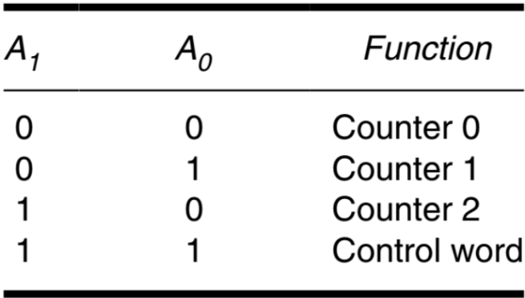

## Pin Configuration

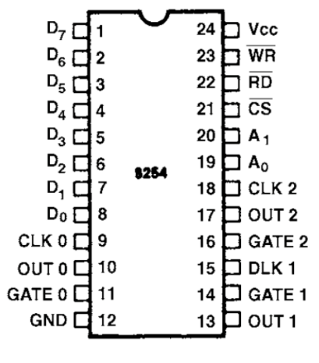

## Internal Architecture

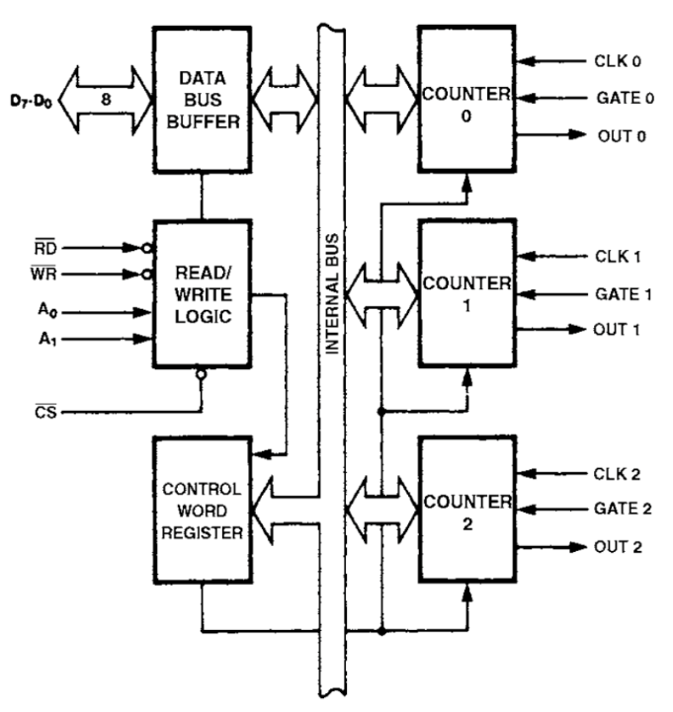

## Kicad Schematic

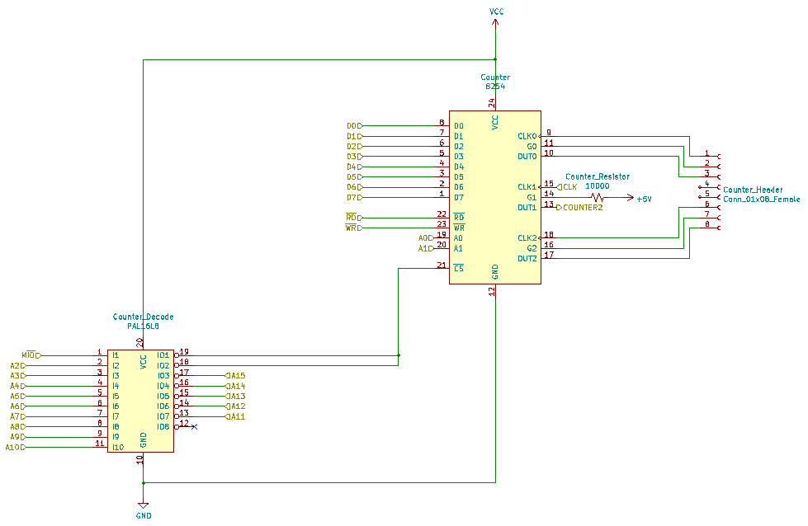

# **8279**

## Device Description

The 8279 is a programmable keyboard interface chip that can scan and encode a matrix of either “keys” or scanlines on a display.

## Pinout

* SL0-3 – used as the direct connections for the rows of the keyboard
* RL0-4 – used as the direct connections for the columns of the keyboard
* A0 – direct connection to the CPU A1 address pin for initial commanding
* CLK – connected to the PCLK output of the 8284 clock generator
* CNTL/STB – connected to the control switch
* SHIFT – connected to the shift switch

## Keyboard

The keyboard is a 4 row 5 column keyboard with 2 extra keys for the shift and control. Appended to this is the NMI switch and interrupt switch on the 8259 to create a whole keyboard matrix.

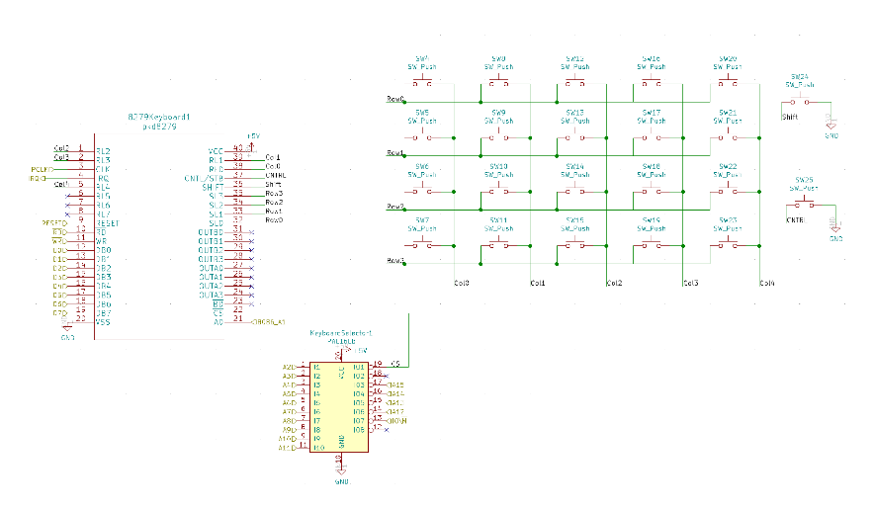

# **16550 UART**

## Device Description

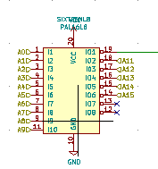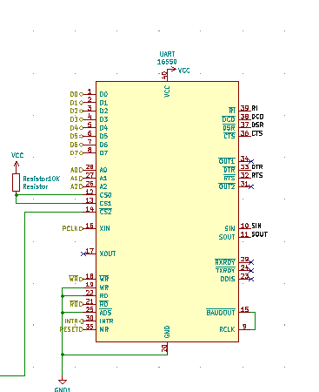The 16550 UART stands for Universal Asynchronous Receiver / Transmitter, and its main purpose is to send and receive serial (bits) data to and from the microcontroller (8086). Essentially, this part is the middle man.

## MAX235 & DSUB

* + 1. MAX235

The MAX235 is a line driver that helps to communicate with the 16550 UART that helps the CPU and data pins be safely transmitted between chips. It alters the signal of incoming data, which reduces the need for error correction.

* + 1. KiCad Schematic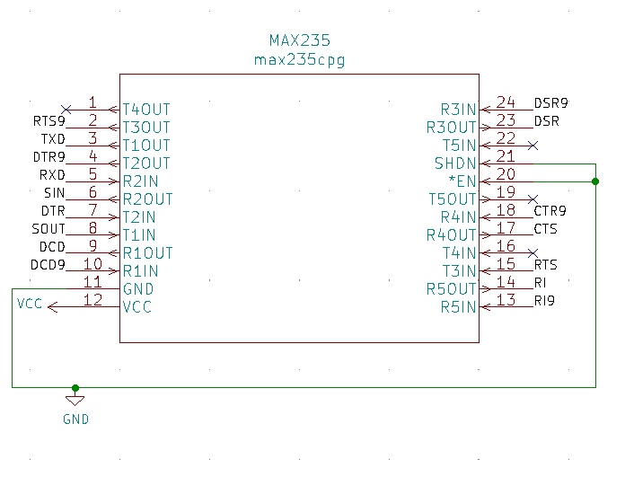



* + 1. DSUB

The DSUB (D-subminiature) electrical connector is an interface connector that interfaces other external chips /devices with the UART. It has a physical connector has 10+ pins on the outside, which allows other parts to interface with the UART.

* + 1. KiCad Schematic

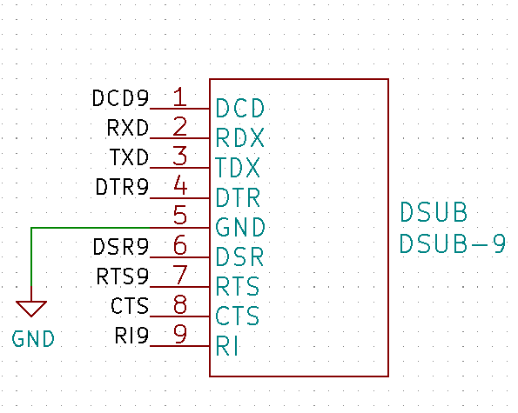

# **LCD Display**

## LCD Description

S6A0069 is a dot matrix LCD driver & controller LSI which is fabricated by low power CMOS technology. It can display 1, 2-line with 5 x 8 or 5 x 11 dots format.

## Pinout

LCD Driver circuit has 16 common and 40 segment signals for LCD driving. Data from CGRAM/CGROM is transferred to 40 bit segment latch serially, and then it is stored to 40 bit shift latch. When each common is selected by 16 bit common register, segment data also output through segment driver from 40 bit segment latch. In case of 1-line display mode, COM1- COM8 have 1/8 duty or COM1 COM11 have 1/11duty, and in 2-linemode, COM1 - COM16 have 1/16 duty ratio.

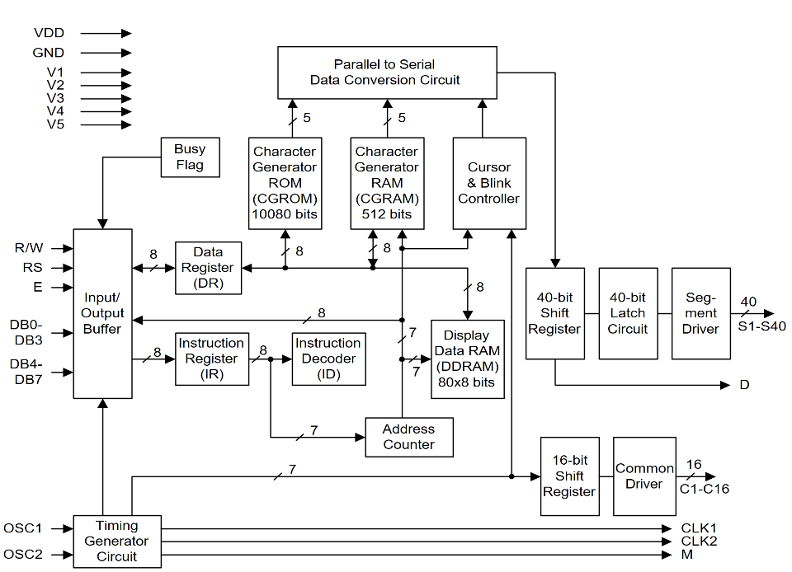

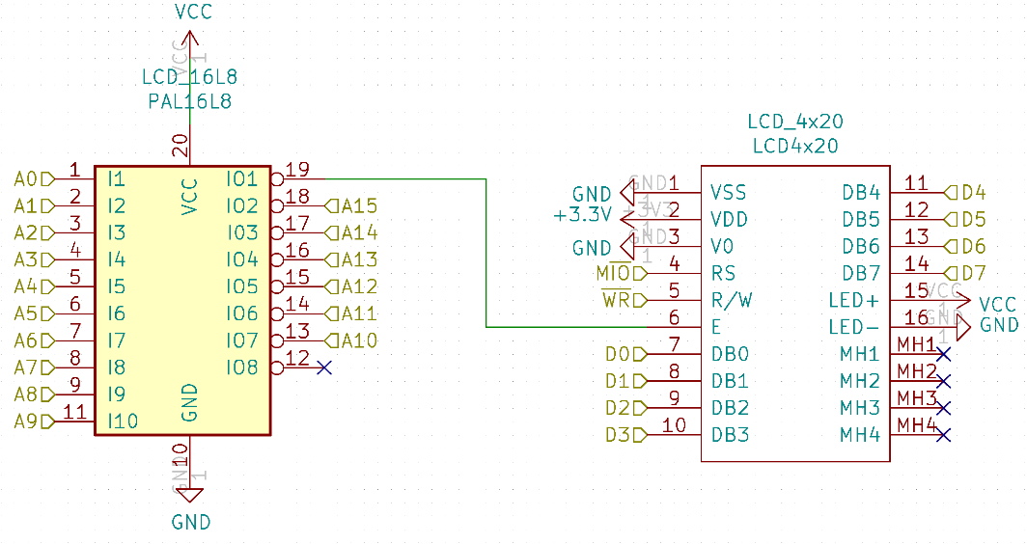

# **7 Segment Displays & LEDs**

## Seven Segment Displays

### Description

Seven-segment displays are a display that houses 7 internal LEDS which represent digits 0-9. When combined with another second display, it can represent digits 0-99. In fact, even today many digital alarm clocks use a seven-segment display to show the time. An advantage of using a seven-segment display is the fact that they are low current displays, meaning they only require a little amount of power to run. As seen in the Kicad schematic below the seven-segment display determines which combination of LEDs to light up based on the inputs given.

### Front and side view

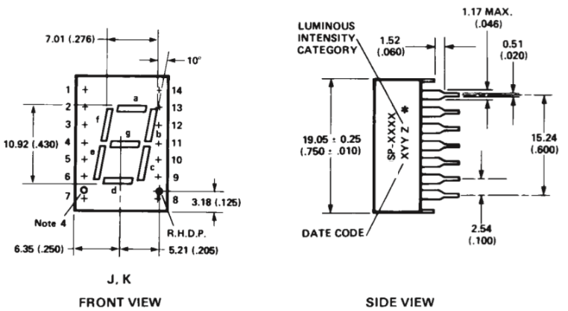

### Display and LED control Bytes

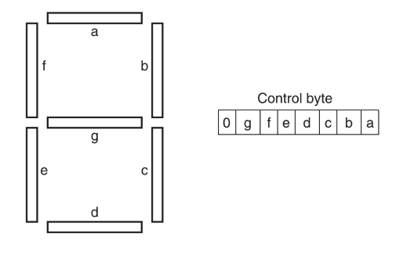

### KiCad Schematic

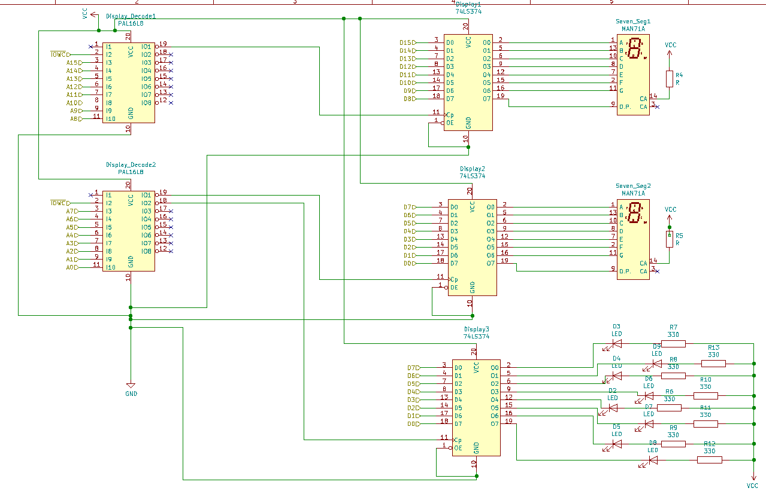

# **74244 8 DIP Switches**

## 74LS244 Description

### 74LS244 Description

Octal buffers and line drivers designed specifically to improve both the performance and density of three-state memory address drivers, clock drivers, and bus-oriented receivers and transmitters.

### Pinout

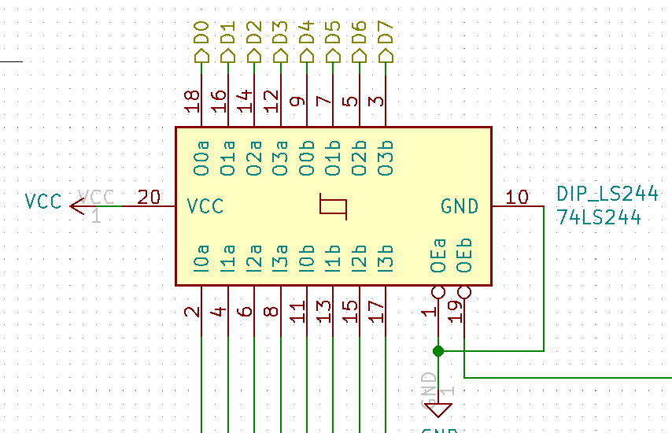

* Pins 2,4,5,8,11,13,15,17: Input from DIP Switches
* Pins 18,16,14,13,9,7,5,3: Output to Data Bus 0-7
* Pin 19: Input from 16L8 Decode

## DIP Switch Description

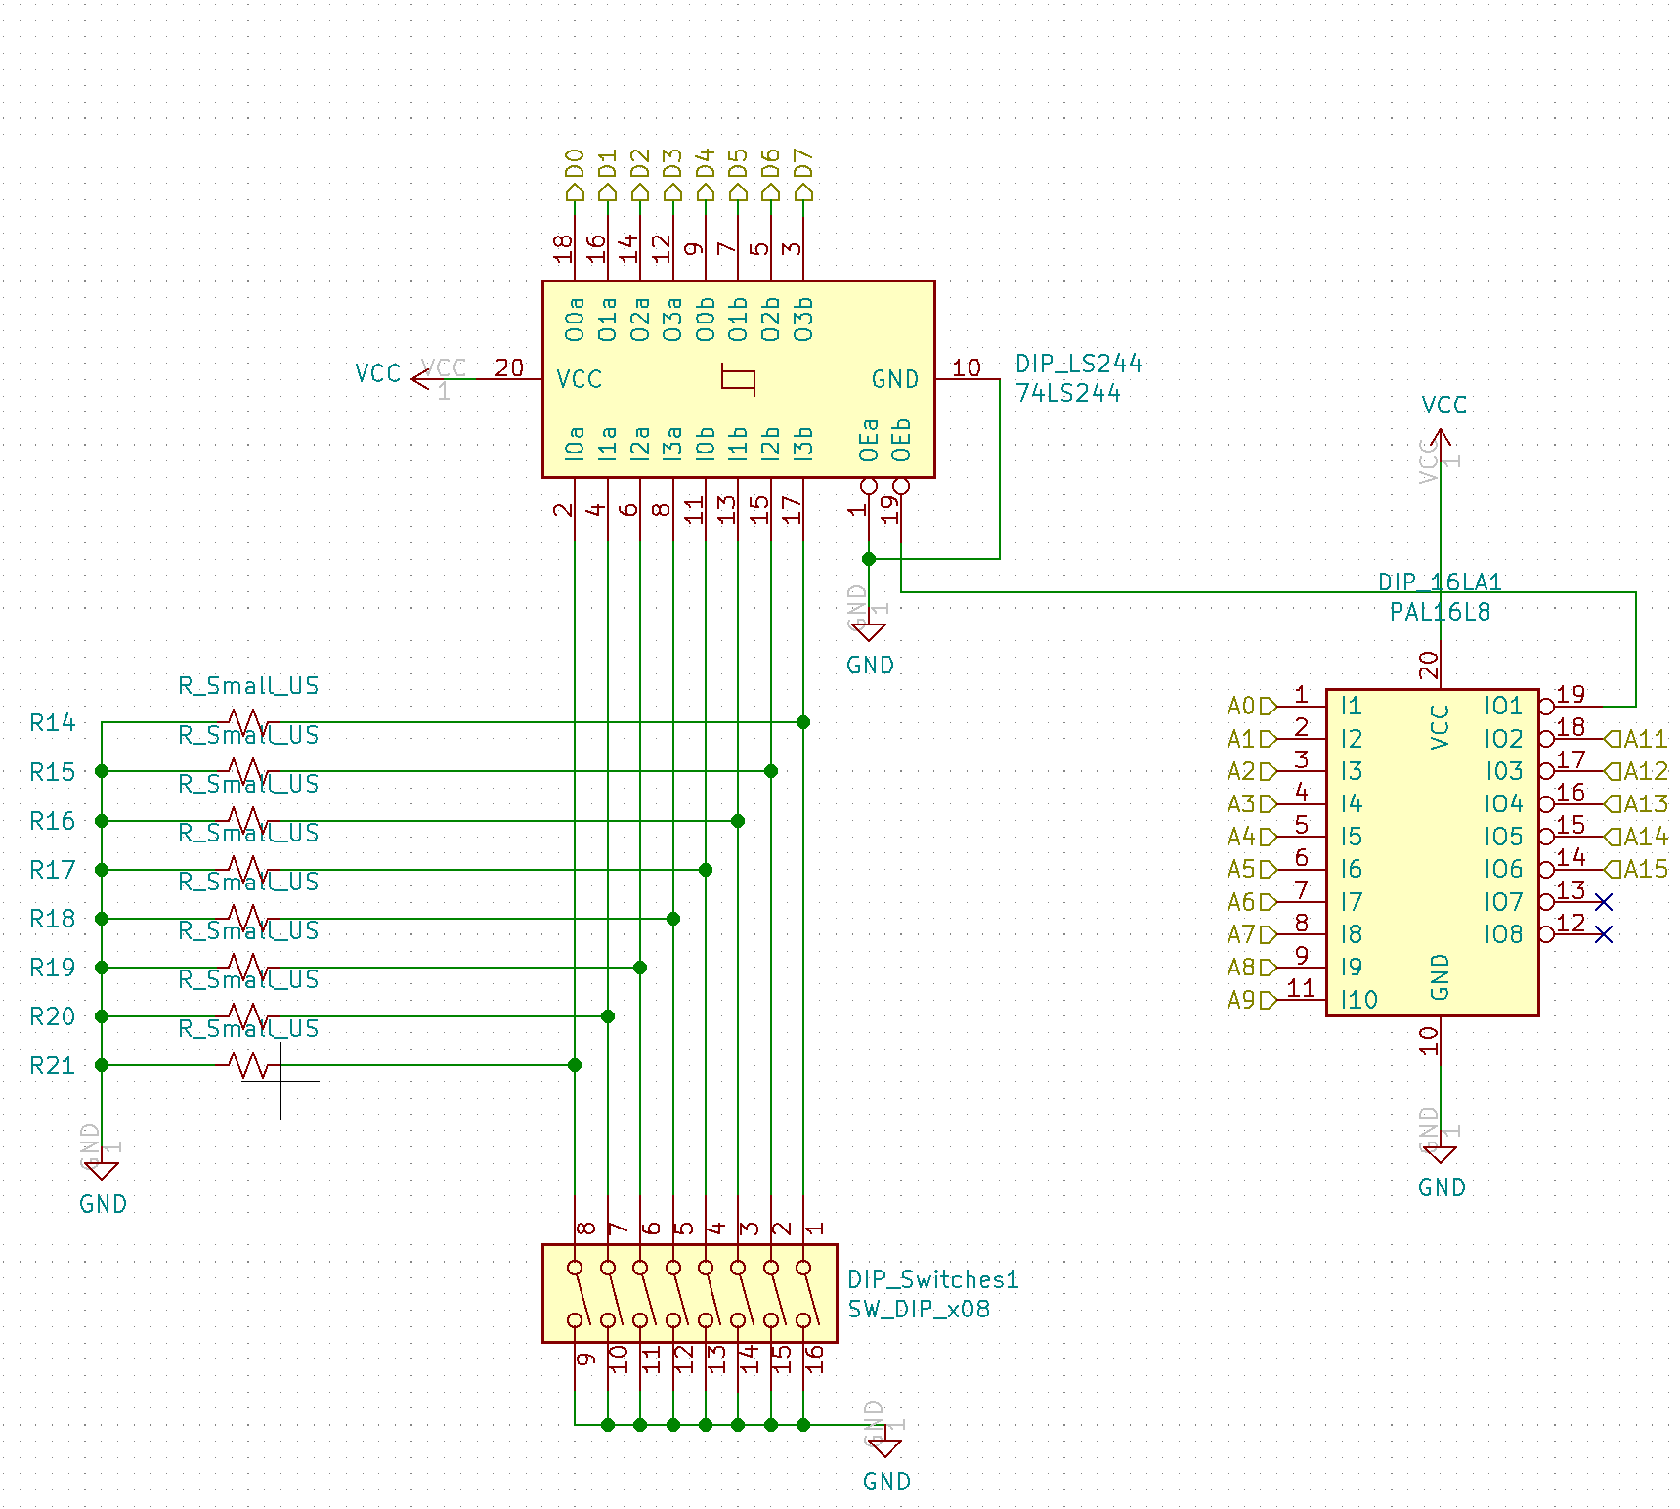Dual in line packaging. These switches are used for selecting pash and for address modification. Used for operation specification for connected devices.

# **Work Distribution**

|  |  |
| --- | --- |
| **Section** | **Team Member** |
| 8086 | Christian Lostoski |
| CMOS Flash Memory | Xavier Smith |
| SRAM | Mick Harrigan |
| 8284A Clock Generator | Andrew Mathew |
| 8255 PPI | Andrew Mathew |
| 8259 | Mick Harrigan |
| 8254 | Andrew Mathew |
| 8279 | Mick Harrigan |
| 16550 UART | Xavier Smith |
| LCD Display | Christian Lostoski |
| 7 Segment Displays | Andrew Mathew |
| 74244 & DIP Switches | Christian Lostoski |
| Power | Christian Lostoski |
| PCB | Xavier Smith |
| Hierarchical Sheet | Andrew Mathew/ Christian Lostoski/ Mick Harrigan/ Xavier Smith |

# **Bill of Materials**

|  |  |  |
| --- | --- | --- |
| **NAME** | **VALUE/TYPE** | **FOOTPRINT** |
| CPU_Switch1 | SW_Push | Button_Switch_THT:SW_CW_GPTS203211B |
| CPU_Capacitor1 | CP1_Small | Capacitor_THT:CP_Axial_L10.0mm_D4.5mm_P15.00mm_Horizontal |
| D1 | CPU_Diode | Diode_THT:D_5KPW_P7.62mm_Vertical_KathodeUp |
| CPU_Resistor1 | R_US | Resistor_THT:R_Axial_DIN0204_L3.6mm_D1.6mm_P1.90mm_Vertical |
| CPU_ADecode1 | 74LS373 | Package_DIP:DIP-20_W7.62mm |
| CPU_ADecode2 | 74LS373 | Package_DIP:DIP-20_W7.62mm |
| CPU_ADecode3 | 74LS373 | Package_DIP:DIP-20_W7.62mm |
| CPU_IO/WR1 | 74LS244 | Package_DIP:DIP-20_W7.62mm |
| CPU_DDecode2 | 74LS245 | Package_DIP:DIP-20_W7.62mm |
| CPU1 | 8086_Min_Mode | Package_DIP:DIP-40_W15.24mm |
| CPU_DDecode1 | 74LS245 | Package_DIP:DIP-20_W7.62mm |
| CRYSTAL1 | Crystal | Crystal:Crystal_AT310_D3.0mm_L10.0mm_Vertical |
| CLK_Resistor1 | 10k | Resistor_THT:R_Axial_DIN0204_L3.6mm_D1.6mm_P1.90mm_Vertical |
| CLK_Resistor1 | 10k | Resistor_THT:R_Axial_DIN0204_L3.6mm_D1.6mm_P1.90mm_Vertical |
| CLK_Resistor1 | 10k | Resistor_THT:R_Axial_DIN0204_L3.6mm_D1.6mm_P1.90mm_Vertical |
| CLK_Capacitor1 | 10uF | Capacitor_THT:CP_Axial_L10.0mm_D4.5mm_P15.00mm_Horizontal |
| CLK_Capacitor1 | 10uF | Capacitor_THT:CP_Axial_L10.0mm_D4.5mm_P15.00mm_Horizontal |
| CLK_Capacitor1 | 10uF | Capacitor_THT:CP_Axial_L10.0mm_D4.5mm_P15.00mm_Horizontal |
| CLK_Switch1 | SW_DPST_x2 | Button_Switch_THT:Push_E-Switch_KS01Q01 |
| CLK1 | 8284 | Package_DIP:DIP-18_W7.62mm |
| CMOS_74LS138 | 74LS138 | Package_DIP:DIP-16_W7.62mm |
| U12 | 74LS04 | Package_DIP:DIP-14_W7.62mm |
| CMOS1 | 28F010 | Package_DIP:DIP-32_W7.62mm |
| CMOS2 | 28F010 | Package_DIP:DIP-32_W7.62mm |
| HighHighSRAM1 | CY7C199 | Package_DIP:DIP-28_W7.62mm |
| LowLowSRAM1 | CY7C199 | Package_DIP:DIP-28_W7.62mm |
| U19 | 74AHC1G08 | Package_DIP:DIP-5-6_W7.62mm |
| U20 | 74AHC1G08 | Package_DIP:DIP-5-6_W7.62mm |
| U21 | 74AHC1G08 | Package_DIP:DIP-5-6_W7.62mm |
| HighLowSRAM1 | CY7C199 | Package_DIP:DIP-28_W7.62mm |
| LowHighSRAM1 | CY7C199 | Package_DIP:DIP-28_W7.62mm |
| U18 | 74LS04 | Package_DIP:DIP-14_W7.62mm |
| U17 | 74LS04 | Package_DIP:DIP-14_W7.62mm |
| SRAMSelector1 | PAL16L8 | Package_DIP:DIP-20_W7.62mm |
| U1 | 74AHC1G08 | Package_DIP:DIP-5-6_W7.62mm |
| PPI1 | 8255 | Package_DIP:DIP-40_W15.24mm |
| PPI_Decoder1 | PAL16L8 | Package_DIP:DIP-20_W7.62mm |
| PPI3 | 8255 | Package_DIP:DIP-40_W15.24mm |
| PPI2 | 8255 | Package_DIP:DIP-40_W15.24mm |
| PPI_Header7 | Conn_01x08_Female | Connector_PinHeader_1.00mm:PinHeader_1x08_P1.00mm_Vertical |
| PPI_Header8 | Conn_01x08_Female | Connector_PinHeader_1.00mm:PinHeader_1x08_P1.00mm_Vertical |
| PPI_Header9 | Conn_01x08_Female | Connector_PinHeader_1.00mm:PinHeader_1x08_P1.00mm_Vertical |
| PPI_Header4 | Conn_01x08_Female | Connector_PinHeader_1.00mm:PinHeader_1x08_P1.00mm_Vertical |
| PPI_Header5 | Conn_01x08_Female | Connector_PinHeader_1.00mm:PinHeader_1x08_P1.00mm_Vertical |
| PPI_Header6 | Conn_01x08_Female | Connector_PinHeader_1.00mm:PinHeader_1x08_P1.00mm_Vertical |
| PPI_Header3 | Conn_01x08_Female | Connector_PinHeader_1.00mm:PinHeader_1x08_P1.00mm_Vertical |
| PPI_Header2 | Conn_01x08_Female | Connector_PinHeader_1.00mm:PinHeader_1x08_P1.00mm_Vertical |
| PPI_Header1 | Conn_01x08_Female | Connector_PinHeader_1.00mm:PinHeader_1x08_P1.00mm_Vertical |
| 8259INTR1 | 8259 | Package_DIP:DIP-28_W15.24mm |
| SW3 | SW_Push | Button_Switch_THT:SW_PUSH-12mm |
| 8259Selector1 | PAL16L8 | Package_DIP:DIP-20_W7.62mm |
| R1 | 10000 | Resistor_THT:R_Axial_DIN0204_L3.6mm_D1.6mm_P2.54mm_Vertical |
| Counter1 | 8254 | Package_DIP:DIP-24_W15.24mm |
| Counter_Decode1 | PAL16L8 | Package_DIP:DIP-20_W7.62mm |
| Counter_Resistor1 | 10000 | Resistor_THT:R_Axial_DIN0204_L3.6mm_D1.6mm_P1.90mm_Vertical |
| Counter_Header1 | Conn_01x06_Female | Connector_PinHeader_1.00mm:PinHeader_1x06_P1.00mm_Horizontal |
| UART1 | 16550 | Package_DIP:DIP-40_W15.24mm |
| SIXTEENL8 | PAL16L8 | Package_DIP:DIP-20_W7.62mm |
| MAX235 | max235cpg | Package_DIP:DIP-24_W7.62mm |
| Resistor10K1 | Resistor | Resistor_THT:R_Axial_DIN0204_L3.6mm_D1.6mm_P2.54mm_Vertical |
| DSUB1 | DSUB-9 | Connector_Dsub:DSUB-9_Female_Horizontal_P2.77x2.54mm_EdgePinOffset9.40mm |
| LCD_16L8 | PAL16L8 | Package_DIP:DIP-20_W7.62mm |
| LCD_4x20 | LCD4x20 | Package_DIP:DIP-20_W7.62mm |
| LCD_4x20 | LCD4x20 | Package_DIP:DIP-20_W7.62mm |
| LCD_4x20 | LCD4x20 | Package_DIP:DIP-20_W7.62mm |
| LCD_4x20 | LCD4x20 | Package_DIP:DIP-20_W7.62mm |
| LCD_4x20 | LCD4x20 | Package_DIP:DIP-20_W7.62mm |
| Display1 | 74LS374 | Package_DIP:DIP-20_W7.62mm |
| Display2 | 74LS374 | Package_DIP:DIP-20_W7.62mm |
| Display3 | 74LS374 | Package_DIP:DIP-20_W7.62mm |
| Seven_Seg1 | MAN71A | Display_7Segment:MAN71A |
| Seven_Seg2 | MAN71A | Display_7Segment:MAN71A |
| Display_Decode2 | PAL16L8 | Package_DIP:DIP-20_W7.62mm |
| Display_Decode1 | PAL16L8 | Package_DIP:DIP-20_W7.62mm |
| R7 | 330 | Resistor_THT:R_Axial_DIN0204_L3.6mm_D1.6mm_P2.54mm_Vertical |
| R13 | 330 | Resistor_THT:R_Axial_DIN0204_L3.6mm_D1.6mm_P2.54mm_Vertical |
| R8 | 330 | Resistor_THT:R_Axial_DIN0204_L3.6mm_D1.6mm_P2.54mm_Vertical |
| R10 | 330 | Resistor_THT:R_Axial_DIN0204_L3.6mm_D1.6mm_P2.54mm_Vertical |
| R11 | 330 | Resistor_THT:R_Axial_DIN0204_L3.6mm_D1.6mm_P2.54mm_Vertical |
| R6 | 330 | Resistor_THT:R_Axial_DIN0204_L3.6mm_D1.6mm_P2.54mm_Vertical |
| R9 | 330 | Resistor_THT:R_Axial_DIN0204_L3.6mm_D1.6mm_P2.54mm_Vertical |
| R12 | 330 | Resistor_THT:R_Axial_DIN0204_L3.6mm_D1.6mm_P2.54mm_Vertical |
| D3 | LED | LED_THT:LED_D1.8mm_W1.8mm_H2.4mm_Horizontal_O1.27mm_Z4.9mm |
| D5 | LED | LED_THT:LED_D1.8mm_W1.8mm_H2.4mm_Horizontal_O1.27mm_Z4.9mm |
| D4 | LED | LED_THT:LED_D1.8mm_W1.8mm_H2.4mm_Horizontal_O1.27mm_Z4.9mm |
| D8 | LED | LED_THT:LED_D1.8mm_W1.8mm_H2.4mm_Horizontal_O1.27mm_Z4.9mm |
| D9 | LED | LED_THT:LED_D1.8mm_W1.8mm_H2.4mm_Horizontal_O1.27mm_Z4.9mm |
| D7 | LED | LED_THT:LED_D1.8mm_W1.8mm_H2.4mm_Horizontal_O1.27mm_Z4.9mm |
| D2 | LED | LED_THT:LED_D1.8mm_W1.8mm_H2.4mm_Horizontal_O1.27mm_Z4.9mm |
| D6 | LED | LED_THT:LED_D1.8mm_W1.8mm_H2.4mm_Horizontal_O1.27mm_Z4.9mm |
| R4 | R | Resistor_THT:R_Axial_DIN0204_L3.6mm_D1.6mm_P2.54mm_Vertical |
| R5 | R | Resistor_THT:R_Axial_DIN0204_L3.6mm_D1.6mm_P2.54mm_Vertical |
| C7 | CP1_Small | Capacitor_THT:CP_Axial_L10.0mm_D4.5mm_P15.00mm_Horizontal |
| C9 | CP1_Small | Capacitor_THT:CP_Axial_L10.0mm_D4.5mm_P15.00mm_Horizontal |
| C11 | CP1_Small | Capacitor_THT:CP_Axial_L10.0mm_D4.5mm_P15.00mm_Horizontal |
| C13 | CP1_Small | Capacitor_THT:CP_Axial_L10.0mm_D4.5mm_P15.00mm_Horizontal |
| C15 | CP1_Small | Capacitor_THT:CP_Axial_L10.0mm_D4.5mm_P15.00mm_Horizontal |
| C17 | CP1_Small | Capacitor_THT:CP_Axial_L10.0mm_D4.5mm_P15.00mm_Horizontal |
| C19 | CP1_Small | Capacitor_THT:CP_Axial_L10.0mm_D4.5mm_P15.00mm_Horizontal |
| C21 | CP1_Small | Capacitor_THT:CP_Axial_L10.0mm_D4.5mm_P15.00mm_Horizontal |
| C23 | CP1_Small | Capacitor_THT:CP_Axial_L10.0mm_D4.5mm_P15.00mm_Horizontal |
| C25 | CP1_Small | Capacitor_THT:CP_Axial_L10.0mm_D4.5mm_P15.00mm_Horizontal |
| C27 | CP1_Small | Capacitor_THT:CP_Axial_L10.0mm_D4.5mm_P15.00mm_Horizontal |
| C3 | CP1_Small | Capacitor_THT:CP_Axial_L10.0mm_D4.5mm_P15.00mm_Horizontal |
| C5 | CP1_Small | Capacitor_THT:CP_Axial_L10.0mm_D4.5mm_P15.00mm_Horizontal |
| C8 | CP1_Small | Capacitor_THT:CP_Axial_L10.0mm_D4.5mm_P15.00mm_Horizontal |
| C10 | CP1_Small | Capacitor_THT:CP_Axial_L10.0mm_D4.5mm_P15.00mm_Horizontal |
| C12 | CP1_Small | Capacitor_THT:CP_Axial_L10.0mm_D4.5mm_P15.00mm_Horizontal |
| C14 | CP1_Small | Capacitor_THT:CP_Axial_L10.0mm_D4.5mm_P15.00mm_Horizontal |
| C16 | CP1_Small | Capacitor_THT:CP_Axial_L10.0mm_D4.5mm_P15.00mm_Horizontal |
| C18 | CP1_Small | Capacitor_THT:CP_Axial_L10.0mm_D4.5mm_P15.00mm_Horizontal |
| C20 | CP1_Small | Capacitor_THT:CP_Axial_L10.0mm_D4.5mm_P15.00mm_Horizontal |
| C22 | CP1_Small | Capacitor_THT:CP_Axial_L10.0mm_D4.5mm_P15.00mm_Horizontal |
| C24 | CP1_Small | Capacitor_THT:CP_Axial_L10.0mm_D4.5mm_P15.00mm_Horizontal |
| C26 | CP1_Small | Capacitor_THT:CP_Axial_L10.0mm_D4.5mm_P15.00mm_Horizontal |
| C28 | CP1_Small | Capacitor_THT:CP_Axial_L10.0mm_D4.5mm_P15.00mm_Horizontal |
| C4 | CP1_Small | Capacitor_THT:CP_Axial_L10.0mm_D4.5mm_P15.00mm_Horizontal |
| C6 | CP1_Small | Capacitor_THT:CP_Axial_L10.0mm_D4.5mm_P15.00mm_Horizontal |
| Power_1 | Conn_01x02_Female | Connector_PinHeader_1.00mm:PinHeader_1x02_P1.00mm_Vertical |
| DIP_Switches1 | SW_DIP_x08 | Button_Switch_THT:SW_CW_GPTS203211B |
| R14 | R_Small_US | Resistor_THT:R_Axial_DIN0204_L3.6mm_D1.6mm_P2.54mm_Vertical |
| R16 | R_Small_US | Resistor_THT:R_Axial_DIN0204_L3.6mm_D1.6mm_P2.54mm_Vertical |
| R17 | R_Small_US | Resistor_THT:R_Axial_DIN0204_L3.6mm_D1.6mm_P2.54mm_Vertical |
| R18 | R_Small_US | Resistor_THT:R_Axial_DIN0204_L3.6mm_D1.6mm_P2.54mm_Vertical |
| R19 | R_Small_US | Resistor_THT:R_Axial_DIN0204_L3.6mm_D1.6mm_P2.54mm_Vertical |
| R20 | R_Small_US | Resistor_THT:R_Axial_DIN0204_L3.6mm_D1.6mm_P2.54mm_Vertical |
| R21 | R_Small_US | Resistor_THT:R_Axial_DIN0204_L3.6mm_D1.6mm_P2.54mm_Vertical |
| DIP_16LA1 | PAL16L8 | Package_DIP:DIP-20_W7.62mm |
| DIP_LS244 | 74LS244 | Package_DIP:DIP-20_W7.62mm |
| R15 | R_Small_US | Resistor_THT:R_Axial_DIN0204_L3.6mm_D1.6mm_P2.54mm_Vertical |
| 8279Keyboard1 | pkd8279 | Package_DIP:DIP-40_W15.24mm |
| SW4 | SW_Push | Button_Switch_THT:SW_PUSH-12mm |
| SW8 | SW_Push | Button_Switch_THT:SW_PUSH-12mm |
| SW12 | SW_Push | Button_Switch_THT:SW_PUSH-12mm |
| SW16 | SW_Push | Button_Switch_THT:SW_PUSH-12mm |
| SW5 | SW_Push | Button_Switch_THT:SW_PUSH-12mm |
| SW9 | SW_Push | Button_Switch_THT:SW_PUSH-12mm |
| SW13 | SW_Push | Button_Switch_THT:SW_PUSH-12mm |
| SW17 | SW_Push | Button_Switch_THT:SW_PUSH-12mm |
| SW6 | SW_Push | Button_Switch_THT:SW_PUSH-12mm |
| SW10 | SW_Push | Button_Switch_THT:SW_PUSH-12mm |
| SW14 | SW_Push | Button_Switch_THT:SW_PUSH-12mm |
| SW18 | SW_Push | Button_Switch_THT:SW_PUSH-12mm |
| SW7 | SW_Push | Button_Switch_THT:SW_PUSH-12mm |
| SW11 | SW_Push | Button_Switch_THT:SW_PUSH-12mm |
| SW15 | SW_Push | Button_Switch_THT:SW_PUSH-12mm |
| SW19 | SW_Push | Button_Switch_THT:SW_PUSH-12mm |
| SW24 | SW_Push | Button_Switch_THT:SW_PUSH-12mm |
| SW25 | SW_Push | Button_Switch_THT:SW_PUSH-12mm |
| SW20 | SW_Push | Button_Switch_THT:SW_PUSH-12mm |
| SW21 | SW_Push | Button_Switch_THT:SW_PUSH-12mm |
| SW22 | SW_Push | Button_Switch_THT:SW_PUSH-12mm |
| SW23 | SW_Push | Button_Switch_THT:SW_PUSH-12mm |
| KeyboardSelector1 | PAL16L8 | Package_DIP:DIP-20_W7.62mm |

# **Block Diagram**

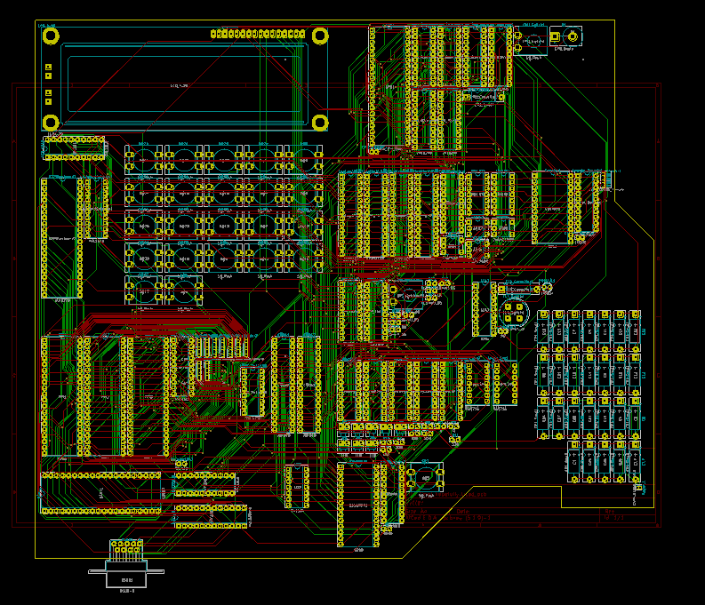

# **3D Model**

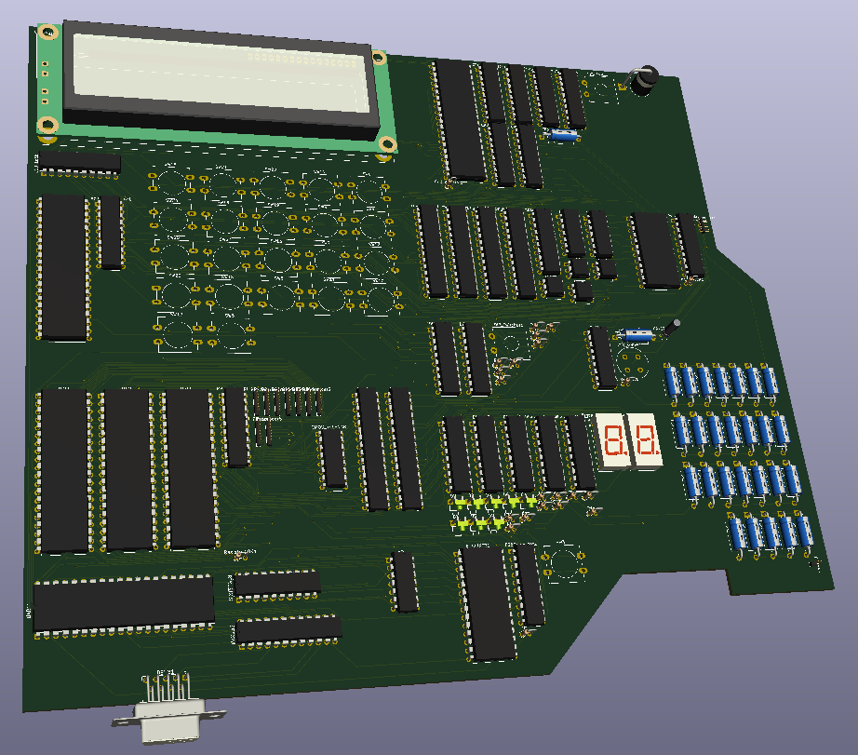

# **Hierarchical Schematic**

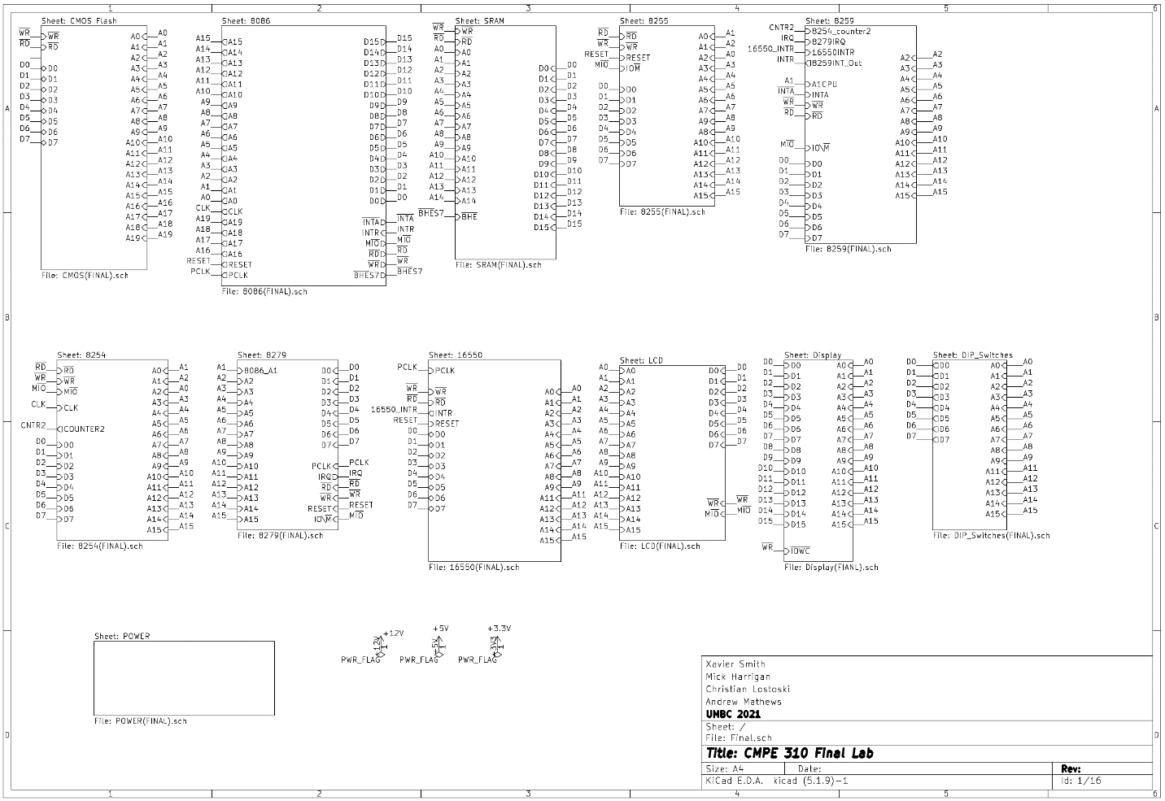

# **Full Schematic**

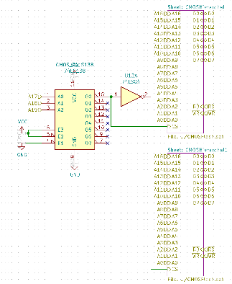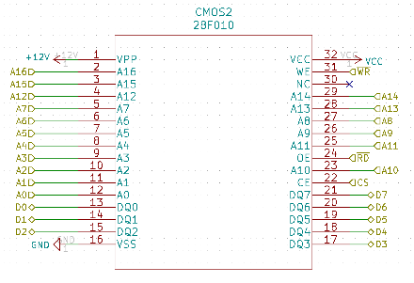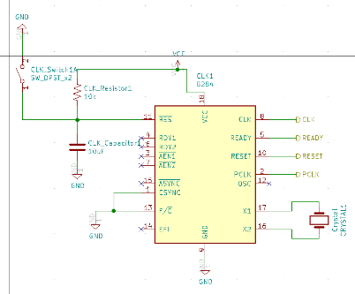

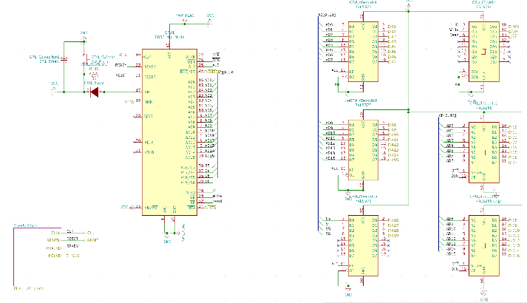

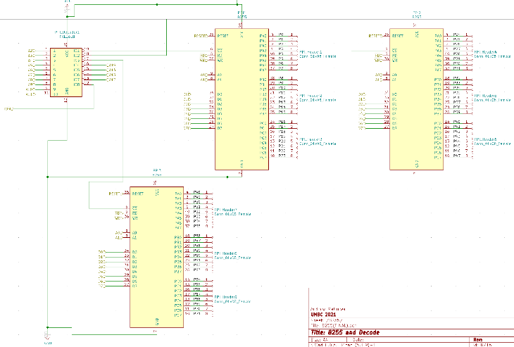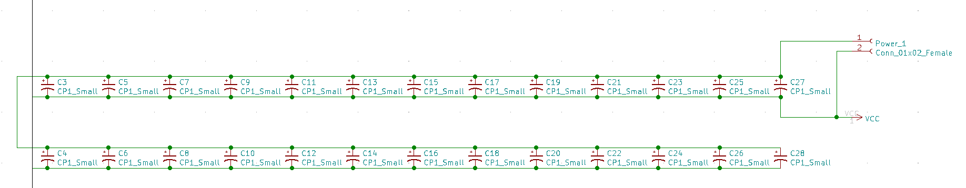

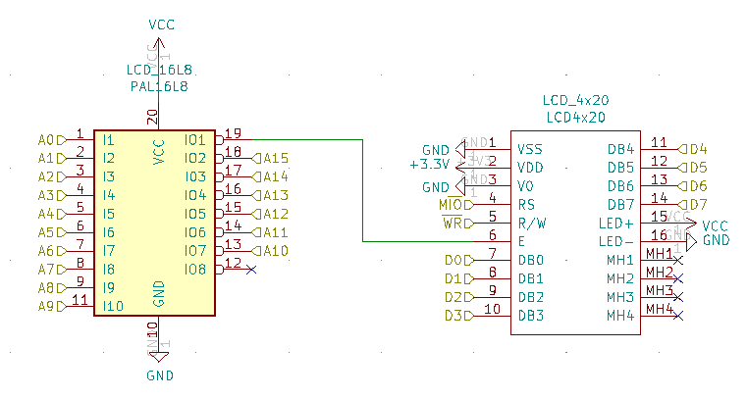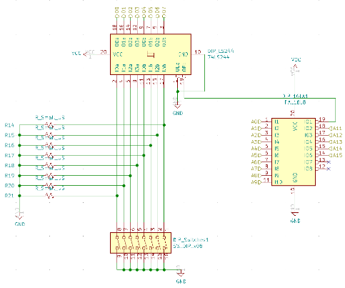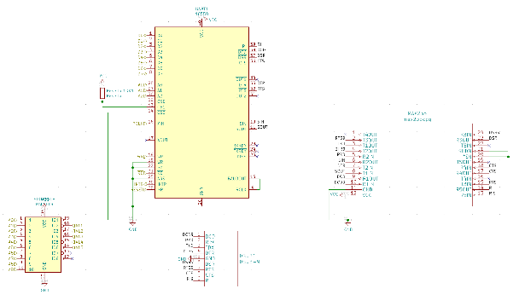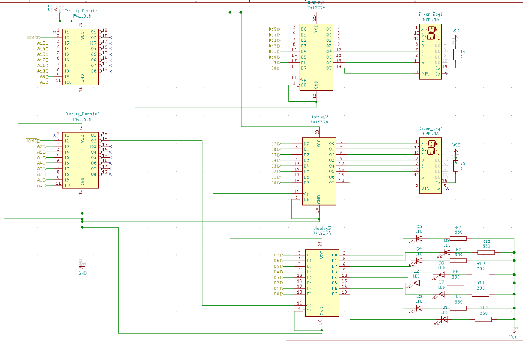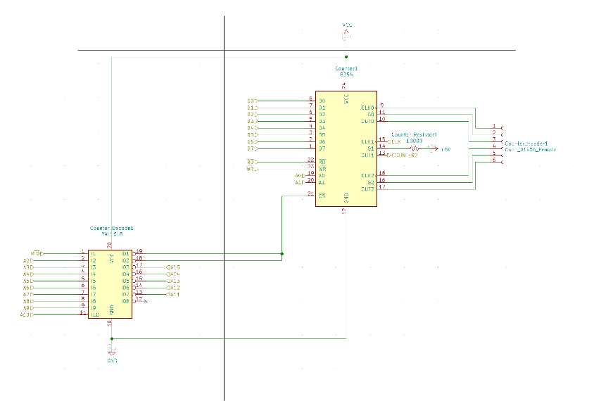

# **Data Sheets**

* 8086
  + <https://www.csee.umbc.edu/courses/undergraduate/CMPE310/Spring15/cpatel2/data_sheets/8086.pdf>
* CMOS Flash
  + [28F010 Datasheet pdf - 1024K (128K x 8) CMOS FLASH MEMORY - Intel (datasheetcatalog.com)](http://www.datasheetcatalog.com/datasheets_pdf/2/8/F/0/28F010.shtml)
* SRAM
  + https://datasheet.octopart.com/CY7C199C-15PXC-Cypress-Semiconductor-datasheet-119543.pdf
* 8284A Clock Generator
  + <https://www.csee.umbc.edu/courses/undergraduate/CMPE310/Spring15/cpatel2/data_sheets/8284A.pdf>
* 8255 PPI
  + <https://www.csee.umbc.edu/courses/undergraduate/CMPE310/Spring15/cpatel2/data_sheets/8255.pdf>
  + <https://www.geeksforgeeks.org/programmable-peripheral-interface-8255/>
* 8259
  + https://pdos.csail.mit.edu/6.828/2010/readings/hardware/8259A.pdf
* 8254
  + <https://www.csee.umbc.edu/courses/undergraduate/CMPE310/Spring15/cpatel2/data_sheets/8254.pdf>
* 8279
  + <https://pdf1.alldatasheet.com/datasheet-pdf/view/66109/INTEL/8279.html>
* 16550 UART
  + [PC16550D Universal Asynchronous Receiver-Transmitter with FIFOs† datasheet (Rev. C) (digikey.com)](https://media.digikey.com/pdf/Data%20Sheets/Texas%20Instruments%20PDFs/PC16550D.pdf)
  + [PC16550D Universal Asynchronous Receiver/Transmitter with FIFOs[dagger] (umbc.edu)](https://www.csee.umbc.edu/courses/undergraduate/CMPE310/Spring15/cpatel2/data_sheets/16550.pdf)
* LCD Display
  + <https://www.csee.umbc.edu/courses/undergraduate/CMPE310/Spring15/cpatel2/data_sheets/LCD_driver_S6A0069.pdf>
* 7 Segment Display
  + <https://www.csee.umbc.edu/courses/undergraduate/CMPE310/Spring15/cpatel2/data_sheets/HDSP_H101_7_seg_dis.pdf>
  + <https://www.electronics-tutorials.ws/blog/7-segment-display-tutorial.html>
* DIP Switches
  + <https://www.csee.umbc.edu/courses/undergraduate/CMPE310/Spring15/cpatel2/data_sheets/8_pos_DIP_switch.pdf>
* Power Block
  + <https://www.csee.umbc.edu/courses/undergraduate/CMPE310/Spring15/cpatel2/data_sheets/Power_term_block.pdf>